1. Double click CURA to open CURA
2. 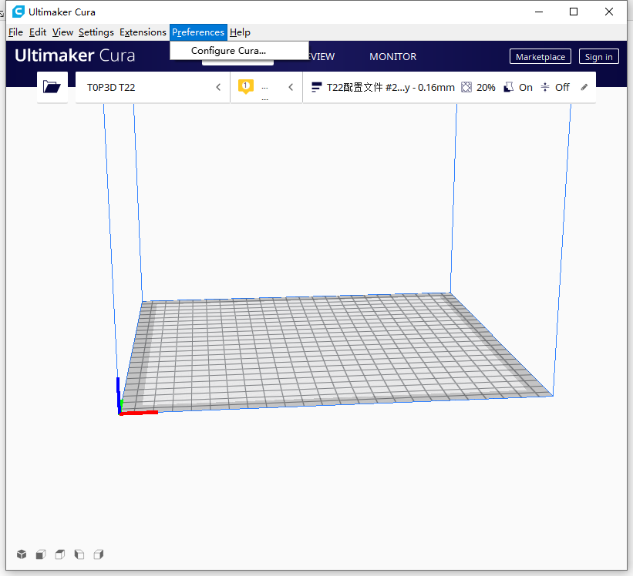Click Configure Cura
3. Select Profiles，Click Import 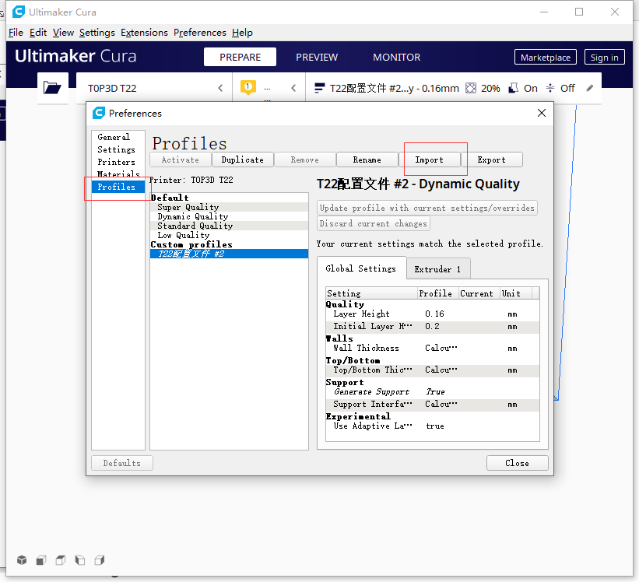
4. Select profile 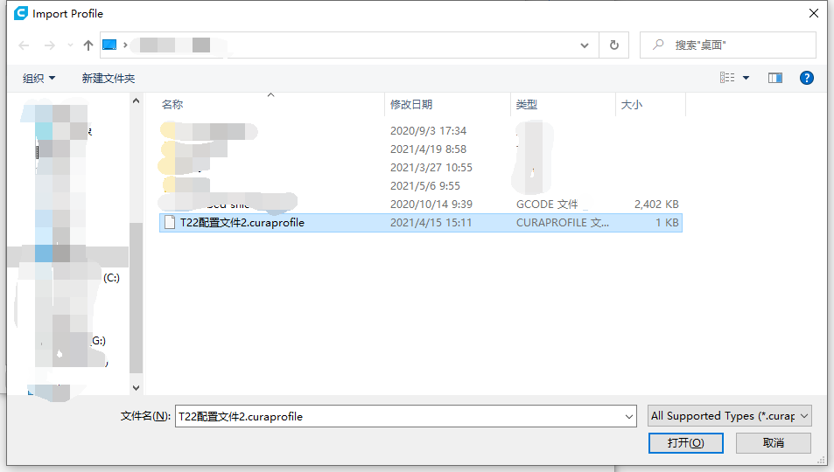 After confirming the configuration file, close the interface and start slicing

T22PRO/MAXPRO Import configuration file